Name:___________________________
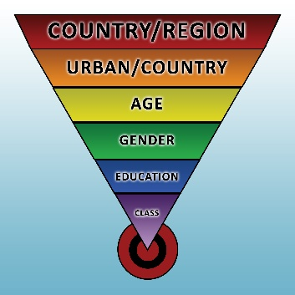

Advertising Samples: Target Audience

Directions: Fill out the chart as we watch examples of how advertisers attempt to target a certain audience.
Describe the advertisement. | Who is the target audience? | How do you know?

