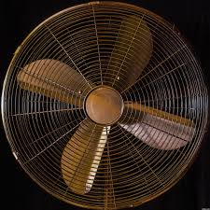
Be a Fan: Kindness Project
People are vacuums
or people are fans.
One,
takes all we have
to fill themselves,
One,
takes all they are
and gives it freely
to us.
Be a fan,
and fresh air
will find Tyler
you, Knott
too. Gregson
Objective: To show the impact of kindness and how it can empower you to make a difference in the world.

Instructions:
Step One: Choose a partner for your project from the same hour. You will share the grade you receive for this project, so choose wisely!

Step Two: Choose a teacher, administrator, or other school employee to shower with kindness (each school employee can only be chosen once!) Remember that one of the goals of this assignment is for your identity to be a secret until you appear and reveal yourself Friday.

Step Three: Partners divide tasks equally and complete them outside of class. You should choose a THEME to help focus your attention. This THEME will need to be consistent and creatively intertwined with each component.

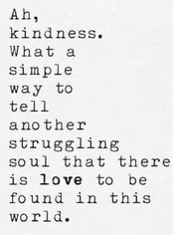
STEP FOUR: Each component should be completed and “delivered” to your person on the day indicated below. Aside from Friday, you may not use class time to deliver these items, so you’ll need to plan ahead and make arrangements outside of class.
Week of Kindness: ____________________
Memorable Monday: Send a quote that explains the impact that your person has made on you. Make sure to keep your theme in mind.
Tasty Treat Tuesday: Bring your person a snack, candy, breakfast, or lunch. Tape a message on to the item that connects to your theme.
Wacky Wednesday: Do something silly to make their day. Remember it needs to connect to your overall theme.
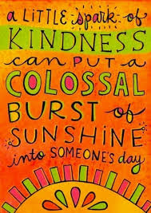
Tell all Thursday: Send your person a letter letting them know the difference they have made in your life. At this point, you can give clues as to who you are but, don’t actually tell them your identity.

Feel Good Friday: Do something you know that would make your person feel good. You will have the first 10-15 minutes of class to complete this task. Don’t take too long!

Be Creative and have fun! Remember you could be creating an experience that this person will remember for years. Make it matter, make a ripple of kindness that lasts as long as the memory of your actions. I would LOVE it if you took pictures and #lesherkindnessproject #beafan each day.

