Dead Words
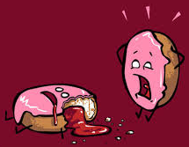
Discuss: What are dead words? Why you should eliminate “Dead Words” from your writing?
OBJECTIVE: To familiarize yourself and your group with your list of dead words. Create a tombstone and eulogy for your word with the help of your group. Present the words in a “funeral” to the class
PART ONE: Some words in the English language tend to be overused and therefore lose their power. These are called Dead Words. In Part One of the project, you will work with a group to find alternatives for some of the most commonly (over) used Dead Words.
Group 1 | Group 2 | Group 3 | Group 4 | Group 5 | Group 6
bad | big | good | finish | happy | fun
know | easy | cool | fast | funny | pretty
get | more | nice | old | really | ugly
small | sad | very | fun | went | soft
mad | mean | said | stupid | a lot | stuff

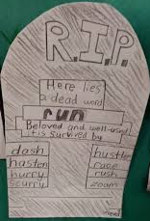
YOUR ASSIGNMENT: On butcher paper, create a tombstone for your word. Write the word at the top of the tombstone. Underneath the name, write the other words by which your dead word is survived. Next, write a brief eulogy (words of remembrance for someone, or in this case something, who has just died) for your word. It served you well while you used it, but its time had come. It is time to replace it with more powerful words. You will read this eulogy at the funeral. Eulogies should be one paragraph in length, no more, no less.
- Each person in your group will choose one dead word from your group’s list
- Use a thesaurus to find AT LEAST 7 alternatives to the dead word. Write these words in a page of your journal.
- After each team member has found his/her 7 words, write all the dead words and their alternatives in your journal.
- Each team member will then compile their dead words/alternatives on butcher paper to create their tombstones.
- Each group member needs to create a eulogy for the word. Have fun with this. You are saying a formal goodbye to this terrible word.
- Each group will present its posters to the entire class at the “Funeral”.
PART TWO: Although you’ve developed a strong relationship with Dead Words over the years, it is now time, as middle school students, to finally put them to rest. Thus, we will hold a funeral for our dead words. After burying these words, you will be forbidden from using any of them in your writing for the rest of your life. It’s time to let go, man.
**Each member of the group should have their own tombstone with their dead word/synonyms and eulogy on the front. Remember the importance of neatness/creativity!
EXAMPLE OF EULOGY FOR THE WORD “HAPPY”:

