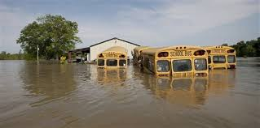
Complete all parts of the Disaster Plan Slide Show.

- Brainstorm ideas and questions.
- Create a Disaster Plan Presentation for Lesher Middle School.
- Present your plan to the class.
- Revise and send your presentation to Assistant Principal Mr. Morrow.

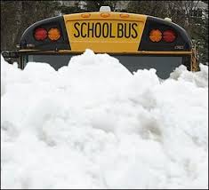
Presentation must include:
- 5 vocabulary words used correctly
- 5 or more slides
- 5 steps carefully explained
- Words, pictures, videos
- A logical order to the plan
- Proper grammar, syntax, and punctuation
- Language of sequencing (transition words)

Vocabulary Words: recovery, severe, prevent, destruction, major, focus, increase, degree, abandon, cycle

Achievement Level | Criterion B: Organizing - Level Descriptor
0 | The student does not reach a standard described by any of the descriptors below.
1-2 | The student:  ii. Organizes opinions and ideas with a minimal degree of coherence and logic.  iii. Makes minimal use of referencing and formatting tools to create a presentation style that may not always be suitable to the context and intention.
3-4 | The student:  ii. Organizes opinions and ideas with some degree of coherence and logic.  iii. Makes adequate use of referencing and formatting tools to create a presentation style that may not always be suitable to the context and intention.
5-6 | The student:  ii. Organizes opinions and ideas in a coherent and logical manner with ideas building on each other.  iii. Makes competent use of referencing and formatting tools to create a presentation style that may not always be suitable to the context and intention.
7-8 | The student:  ii. Effectively organizes opinions and ideas in a coherent and logical manner with ideas building on each other in a sophisticated way.  iii. Makes excellent use of referencing and formatting tools to create an effective presentation style.

Achievement Level | Criterion D: Using Language – Level Descriptor
0 | The student does not reach a standard described by any of the descriptors below.
1-2 | The student:  i. Uses limited range of appropriate vocabulary and forms of expression.  iii. Uses grammar, syntax, and punctuation with limited accuracy; errors often hinder communication.
3-4 | The student:  i. Uses an adequate range of appropriate vocabulary, sentence structures and forms of expression.  iii. Uses grammar, syntax, and punctuation with some degree of accuracy; errors sometimes hinder communication.
5-6 | The student:  i. Uses a varied range of appropriate vocabulary, sentence structures and forms of expression competently.  iii. Uses grammar, syntax, and punctuation with a considerable degree of accuracy; errors do not hinder effective communication.
7-8 | The student:  i. Effectively uses a varied range of appropriate vocabulary, sentence structures, and forms of expression.  iii. Uses grammar, syntax, and punctuation with a high degree of accuracy; errors are minor and communication is effective.

