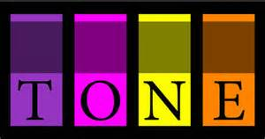
WORD LIST:

TONE (POSITIVE)
Happiness
amiable cheery
contented ecstatic
jovial lighthearted
serendipitous exuberant
jubilant sprightly
genial impish

Pleasure
enraptured peaceful playful whimsical satisfied
amused appreciative enthusiastic encouraging sanguine

Friendliness, Courtesy
accommodating approving compassionate cordial courteous reverent
forgiving gracious indulgent kindly obliging
pitying sociable solicitous soothing sympathetic
tender tolerant trusting consoling benevolent

Animation
ardent brisk crisp eager earnest
ecstatic energetic exalted feverish hasty
hearty hopeful inspired lively rapturous
vigorous impassioned elated
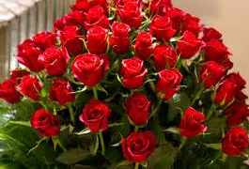
Romance Tranquility
affectionate sensual meditative optimistic
amorous erotic serene idyllic
tender lustful dreamy soothing
passionate spiritual hopeful

TONE (NEUTRAL)
General
authoritative baffled ceremonial clinical detached
disbelieving factual formal informative erudite
matter-of-fact nostalgic objective questioning urgent
reminiscent restrained sentimental shocked inquisitive
dispassionate

Rational/Logical
admonitory argumentative candid coaxing analytical
quizzical deliberate didactic frank insinuating
instructive oracular pensive pleading preoccupied
sincere unequivocal probing
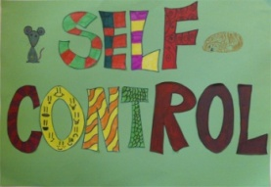
Self-Control
solemn serious gentle temperate
imperturbable stoic prudent cautious
nonchalant cool wary

Apathy
blasé bored colorless defeated dispassionate
indifferent inert languid monotonous resigned
sluggish sophisticated vacant apathetic

TONE (HUMOR/IRONY/SARCASM)
amused bantering bitter caustic comical
condescending contemptuous cynical disdainful droll
facetious flippant giddy humorous insolent
ironic irreverent malicious mocking patronizing
pompous ribald ridiculing sarcastic sardonic
satiric scornful sharp silly taunting
teasing wry belittling haughty insulting
playful hilarious uproarious

TONE(NEGATIVE)
General
agitated arrogant artificial audacious belligerent
brash childish coarse cold condemnatory
contradictory desperate disappointed disgruntled disgusted
disinterested passive furious harsh indignant
inflammatory irritated manipulative obnoxious quarrelsome
shameful superficial surly threatening foreboding
uninterested menacing vindictive callous

Sadness
despairing despondent foreboding gloomy bleak
melancholy maudlin regretful remorseful grim
somber*

Pain
annoyed crushed dismal fretful irritable
miserable mournful pathetic plaintive querulous
sulky sullen troubled uneasy vexed
Unfriendliness
belittling boorish curt demeaning disparaging
impudent pitiless scolding spiteful suspicious
unsociable reproachful

Anger
belligerent furious livid wrathful savage
enraged volatile disgruntled scornful

Passion
fierce frantic avaricious voracious hysterical
insane impetuous impulsive jealous nervous
reckless insistent uncompromising

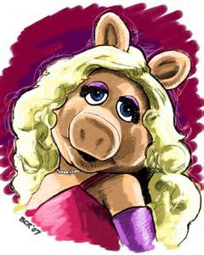
Arrogance/Self-Importance
boastful bold pretentious supercilious pedantic
didactic bombastic self-righteous assured confident
defiant* dignified domineering egotistical imperious
smug* lofty peremptory resolute saucy

Sorrow/Fear/Worry
aggravated anxious apologetic apprehensive disturbed
embarrassed intimidated grave hollow morose
ominous paranoid pessimistic poignant enigmatic

Submission/Timidity
aghast alarmed ashamed astonished astounded
contrite self-deprecatory docile groveling ingratiating
meek modest obsequious servile sycophantic
timid tremulous unpretentious introspective

