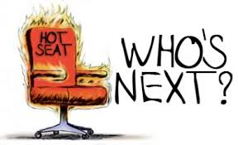
Fall Tone Word Review #1
Stargirl
Instructions: Read each passage and decide which of your Fall Tone words is the best match. Make sure to read carefully and really consider the VERY best match for each passage.

- “She’s not real,” Hillari said. She was sneering. “She’s an actress. It’s a scam.”
Someone called out, “Who’s scamming us?”
“The administration. The principal who else? Who cares?” Hillari wagged her head at the absurdity of the question.
A hand flashed in the air: “Why?”
“School spirit,” she spat back. “They think this place was too dead last year. They think if they plant some nutcase in with students—” (Spinelli, 7)

_____________________________________
- “We wanted to define her, to wrap her up as we did each other, but we could not seem to get past “weird” and “strange” and “goofy.” Her ways knocked us off balance. A single word seemed to hover in the cloudless sky over the school: HUH?” (Spinelli, 11).

______________________________________
- “We joined her as she sang “Happy Birthday” to us in the lunchroom. We heard her greet us in the hallways and classrooms, and we wondered how she knew our names and our birthdays” (Spinelli, 15).

______________________________________
- “In terms of achievement, Wayne Parr seemed to be a nobody. He played on no sports team, joined no organization, won no awards, earned no A’s. He was elected to nothing, honored for nothing…” (Spinelli, 19).

______________________________________
- “Hillari paused. Her eyes narrowed. She jabbed her finger in Stargirl’s face. “Don’t try singing to me, I’m warning you.” Only those at nearby tables heard Stargirl’s faint reply: “I won’t sing to you.” Hillari gave a satisfied smirk and walked off” (Spinelli, 27)

______________________________________
- “Everyone cheered: the spectators, the cheerleaders, the band, the players, the officials, the parents running the hot dog stand, the policeman, me. We whistled and stomped our feet on the aluminum bleachers” (Spinelli, 23).

______________________________________

- “Also, I think we were all waiting to see the outcome of an event that loomed larger and larger with every passing day. The next birthday coming up was Hillari Kimble’s” (Spinelli, 26).
______________________________________
- “On the contrary, she is one of us. Most decidedly. She is us more than we are us. She is, I think, who we really are. Or were” (Spinelli, 32). “You’ll know her more by your questions than by her answers. Keep looking at her long enough. One day you might see someone you know” (Spinelli, 34)
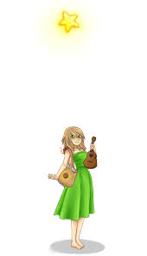
______________________________________
- “What about her parents?” said Kevin.
“What about them?”
“What do they think?”
Archie shrugged. “I guess they agree.”
“What do they do?” Kevin said
“Breathe. Eat. Clip their toenails” (Spinelli, 34).

_______________________________________
- “Hillari Kimble was standing at the upper landing, grinning. She was holding Cinnamon the rat, dangling by its tail over the railing, nothing but space between it and the first floor. Stargirl was on the steps below, looking up” (Spinelli, 37).

_______________________________________

