Fall Tone Word Review #2
Stargirl
Instructions: Read each passage and decide which of the Fall Tone words below is the best match. Make sure to read carefully and really consider the VERY best match for each passage.

benevolent
callous
incredulous
jovial
remorseful
sanguine
reverent
foreboding

- “The Pledge of Allegiance, the Grisdale funeral, the Danny Pike affair—these things were noted, but they had no immediate impact on Stargirl’s popularity at school. Not so with cheerleading and the boy’s basketball season” (Spinelli 47)

_________________________________________________
- “It was the worst slaughter of the year. Red Rock was helpless. By the start of the fourth quarter we were ahead, 78 to 29. The coach put in the subs. We booed. We smelled a hundred points. We wanted blood. The coach put the starters back in. As we howled and thundered in the stands, Stargirl got up and walked from the gym. Those of us who noticed assumed she was going to the rest room. I kept glancing toward the exit. She never returned” (Spinelli 53).

__________________________________________________
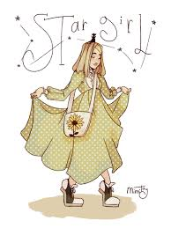
- “She held his head in her lap while the others attended his broken leg. Her hands moved over his face and forehead. She seemed to be saying things to him. When they carried him away on a stretcher, she followed. Everyone—both sides—stood and applauded. The Sun Valley cheerleaders leaped as if he had just scored two points” (Spinelli 70).

___________________________________________________
- ”We were shocked. We couldn’t believe it. And then, as the seconds of the fourth quarter ticked by, we did believe. The cheers from across the gym were like volleys of arrows piercing our grand delusion (Spinelli 71).

___________________________________________________
- “She shook her fists at us. She flung her defiance at our gloom. And then her face was bloody. A Glendale player had just dunked the ball and Kevin pounded my knee with his fist and I looked to see Stargirl’s face suddenly a bloody mask and I was on my feet screaming, ‘NOOOO!’” (Spinelli 72)
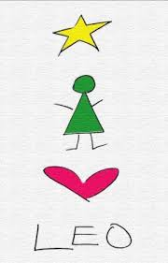
- “When?”
“Today. After school. Just now!
“I don’t believe it!”
“I don’t believe it took so long.”
“Kicked off? Are they allowed?”
“Sure. Why not? It’s not her school.”
(Spinelli 77).

_________________________________________________
- “On weekends and after dinner, we delivered many potted violets. And CONGRATULATIONS! balloons. And cards of many sentiments. She made her own cards. She wasn’t a great artist. Her people were stick figures. The girls all had triangle skirts and pigtails. You would never mistake one of her cards for a Hallmark, but I have never seen cards more heartfelt. They were meaningful in the way that a school child’s homemade Christmas car is meaningful. She never left her name” (Spinelli 112).
_________________________________________________
- “Leo, this has never happened in Mica before, having a winner of the Arizona state oratorical contest. One of their very own. When they hear about it, they’re going to go bananas. And when they get a gander at me and that trophy—” (Spinelli 147).

_________________________________________________
- “We were all on our feet, clapping and shouting and whistling. I found myself sobbing. The cheering was as wild as that of the crowd at a championship basketball game” (Spinelli 156).

__________________________________________________
- “She liked you, boy.”
The intensity of his voice and eyes made me blink. “Yes,” I said.
“She did it for you, you know.”
“What?”
“Gave up her self, for a while there. She loved you that much. What an incredibly lucky kid you were.
I could no look at him. “I know.”
He shook his head with wistful sadness. “No, you don’t. You can’t know yet. Maybe someday…”
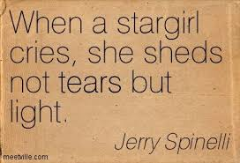
I knew he was tempted to say more. Probably to tell me how stupid I was, how cowardly, that I blew the best chance I would ever have” (Spinelli 178).

___________________________________________________

Tone in Images

INTRUCTIONS: Identify which of your fall tone words below best fits the image.

admonitory patronizing cynical amiable reverent incredulous
