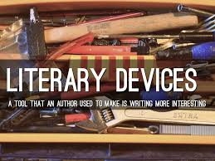
- metaphor- figure of speech that makes a _______________________ between two seemingly unlike things
- simile- a figure of speech that uses like or as to compare seemingly _____________________ things
- personification- a figure of speech that an animal, object, a force of nature, or an idea is given _________________________ characteristics.
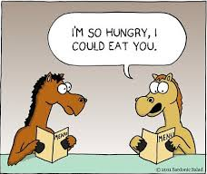
- imagery- _________________________ language that speaks to one or more of the 5 senses (sight, smell, taste, touch, sound)
- hyperbole- a figure of speech that uses exaggeration to express strong _________________, make a point or evoke humor
- allusion- a reference to a well-known character, place, or situation from history, music, art, or another work of ______________________
- anaphora- repetition of a _______________ or phrase usually to prove a point.
- symbol- any person, animal, place, object, or event that exists on a literal level within a work but also represents something on a figurative ____________________
- flashback- is a literary __________________ in which an earlier event is inserted into the normal chronological order of a narrative. To put it simply it is a scene from the past.
- setting- the time and ________________ in which the events of a work of literature take place.
- point of view (POV)- the vantage point from which the ________________ is told.
- 1st person POV- __________ of the characters is the narrator; uses “I”
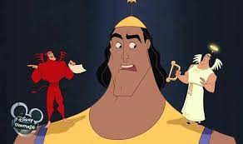
- 3rd person limited- the narrator, who plays no part in the story, ___________________ in on the thoughts and feelings of just one character
- 3rd person omniscient- all knowing (Santa); the person telling the story knows everything there is to know about the characters and their ______________________
- conflict- a struggle between two opposing forces
- external conflict- a struggle with an _____________________ source.
- internal conflict- takes place in the character’s own ____________________
- characterization-is the__________________ by which the writer reveals the personality of a character.
- indirect characterization-the author _____________ us the character but allows us to interpret for ourselves what kind of person the character is
- direct characterization-the author tells readers directly what a _________________ is like or what a person’s motives are
- antagonist- is a character in a _________________ of literature who opposes the main character.
- protagonist-is the leading character, or one of the _________________ characters in a work of literature.
- dialect-refers to a variety of a language that can signal the speaker’s regional or social _______________________
- dialogue-it is a conversation between two or ___________________ people in a work of literature
- foil- is another character in a story who contrasts with the _________________ character, usually to highlight one of their attributes.
- foreshadowing- hinting at something that is or could happen in the __________________
- irony- a contrast between what you expect to happen and what actually __________________________
- theme- the moral or _____________________ taught throughout the story
- mood- are the emotions that the ________________creates and you feel while you are reading.
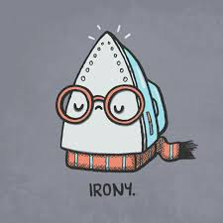
- diction- the ________________ an author chooses to use in a piece of literature
- denotation- the dictionary definition of a ________________; the literal meaning
- connotation- the thoughts and feelings associated (connected) with the word; how a word makes you _________________ (positive or negative)
- stereotype- a picture in your head or an opinion you have, about a _______________ or group of people based on the actions or behaviors of others that are similar.
- suspense- a state or _____________________ the author creates of excited or anxious uncertainty about what may happen
- plot- the sequence of _____________________ in a story

