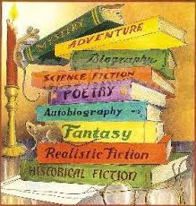
Reading Interest Survey
Help me help you! I want to know about your current reading habits and favorite genres to understand you as a reader.
- Do you like to read? YES No Sort of
Explain:______________________________________________________
- Do you like to read in groups? YES NO
- Do you like to read aloud? YES NO
- Do you like it when someone else reads to you? YES NO
- Do you like to talk to your friends about what you read?
- How much time do you spend reading? min. per day ___________ min. per week ___________
- What are some of the books you have read? _________________________________________________
_________________________________________________________________________________________________________________
- What do you do when you come to a word you don’t know?
- Which do you prefer reading? Circle one. Fiction Non-fiction
- What type of characters do you like reading about? Circle all that apply. Animals
Musicians Athletes Historical Figures Celebrities Detectives People Like Me
People Not Like Me People My Age Fantasy Actors People Going Through the Same Issues
- What do you read most of the time? Circle One.
Books Magazines Graphic Novels Books on Tape Websites Newspapers Textbooks Comic Books
- What is your favorite book?_________________________________________________________________________
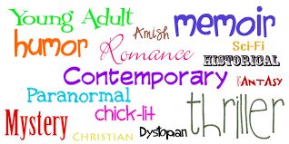
- How many books do you own? ________________________
- Circle the genre or types of reading material you like.

