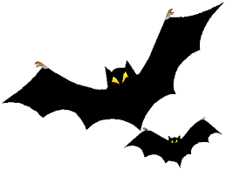
Scary Story
Contest 2016
A 30 year Lesher tradition
Write an original scary story that has no more than 500 words. Remember: these are short stories!
STORIES NEED TO BE TYPED AND INCLUDE STUDENT NAME, GRADE, AND TEACHER. STORIES SHOULD BE IN MRS. MARSH’S BOX IN THE OFFICE AT THE END OF THE DAY ON Monday, OCTOBER 24.
Purpose: To entertain! To scare! To creep-out your teachers and your classmates!
Audience: your classmates (winning stories will be read on KLIB!), your families, and the judges Mrs. Marsh and Mr. Sterling.
While these stories are supposed to be scary, please make sure they are still family and school-appropriate (if you don’t want your little sister, your grandma, or Mr. Dodd to read what you’ve written, it probably isn’t family and school appropriate).

Prizes: STUDENTS WITH WINNING STORIES WILL BE HONORED ON MONDAY, OCTOBER 31, during the three lunches—LOTS OF PRIZES AND CAKE AND PUNCH!

