SketchNotes
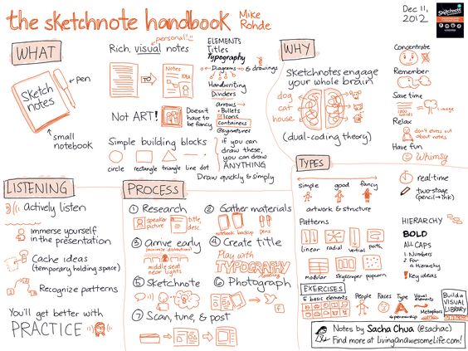
Introduction: For many years researchers have been proving that writing out notes helps you retain knowledge. The problem we tend to run into is taking notes by hand or really at all is dull and monotonous, but there is information we need. So how can we make it fun?
Objective: To create notes we will remember and have fun doing it!
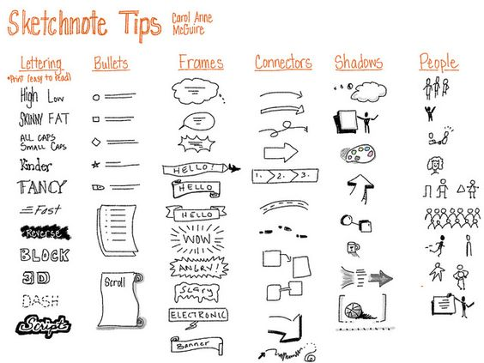
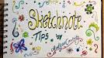
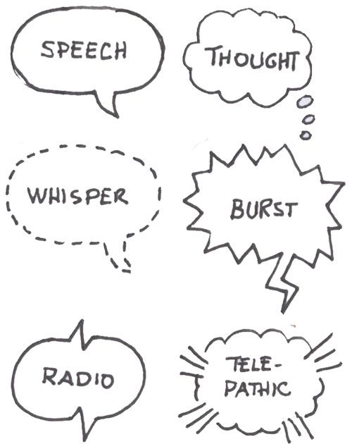
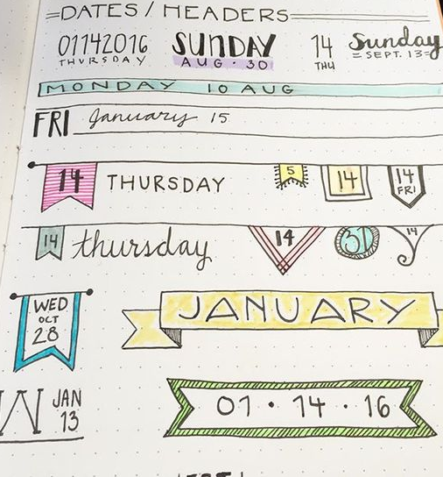
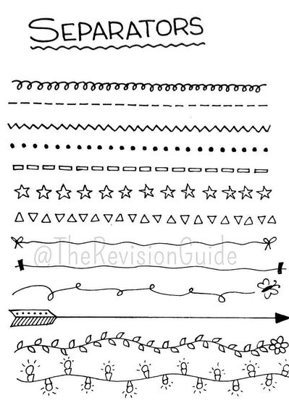

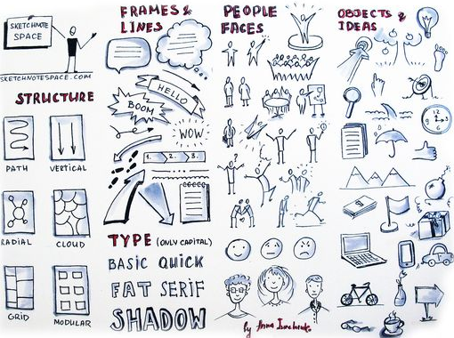

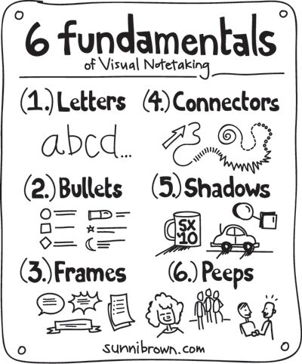
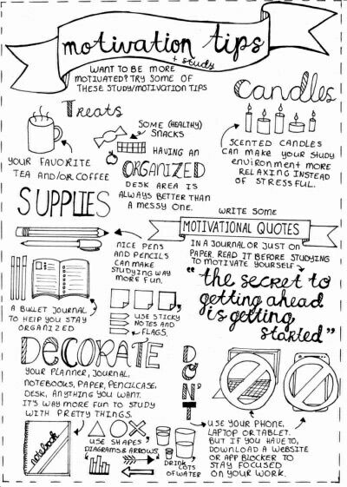
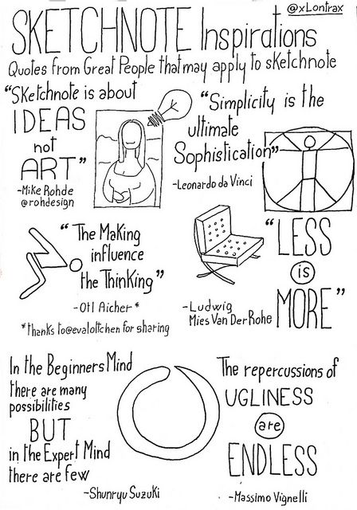
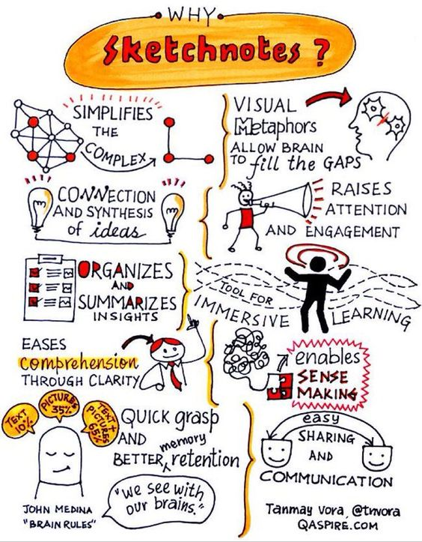
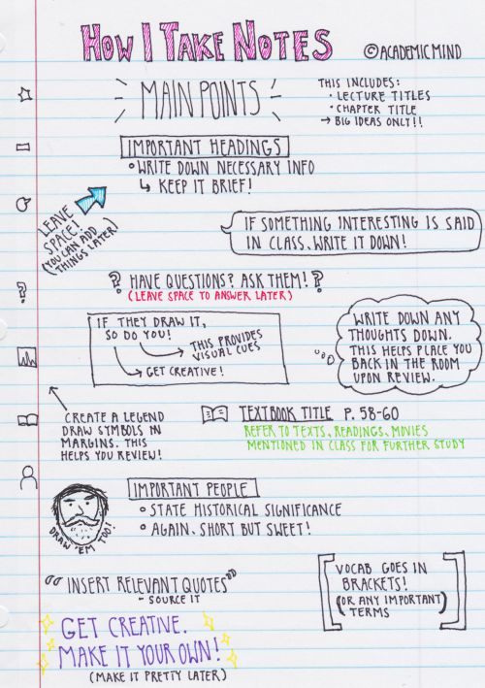

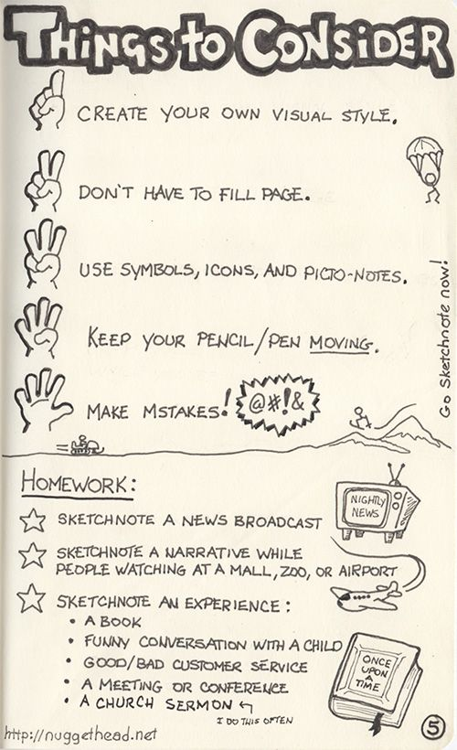
APPLY: Let’s give it a try! First, go to the first page of your composition notebook and put your name in the middle then like the image below create words and images of things you love and that make you happy.
NEXT: Choose one the three homework options from the Things to Consider image.
Reminder!!! This is a process and you will get better with time.
