Sketchnotes
OBJECTIVE:
Create notes you will remember and enjoy doing it in the process!
TITLE PAGE:
Before you get started on your novel notes you want to create a Title Page. So, this means just have fun and be creative! Basically you are creating a cover for the book using sketchnotes.
REQUIREMENTS:
You need to have a minimum of one page of notes for every three chapters we read.
Your notes should include a minimum of the following:
- Two quotes (just something you liked/enjoyed, thought was funny)
- Three literary terms (from your flashcards: setting, examples of characterization, simile etc.)
- Important events or information
- 5-7 images/sketches
- At least one questions
- At least three unfamiliar vocabulary word with synonym
Other notes to consider (not required, but you might need them to fill space)
- Your thoughts about a character
Example:
- Predictions you have for the next chapter
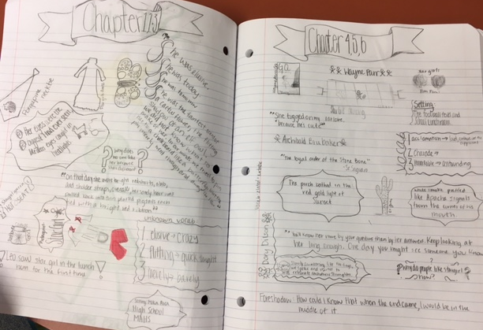
REMINDERS:
Make sure to use your Legend/Key and stay organized!
