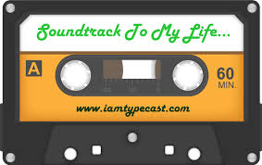
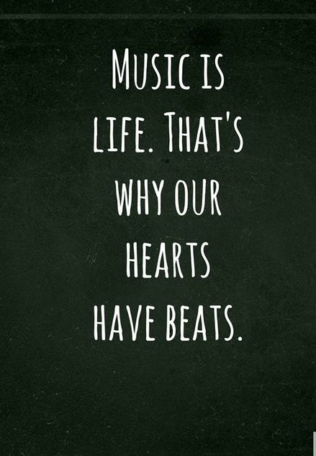
INTRODUCTION: Music has the power to shape our lives. In our recollections of the past we might hear a tune softly playing in the background. Many of us spend time searching for the perfect songs to express our emotions or experiences. We are all trying to make sense of the same universal problems and celebrating essentially the same life events. When we hear a song from the past it seems like if we were to concentrate hard enough we could be zapped back to that exact moment in our lives. So ask yourself, what is the soundtrack to your life?
Due Date:_________________

OBJECTIVE: To develop a list of events and songs that connect to each event as well as create a CD/Album cover that depicts your life.

STEP 1: Brainstorm.
Make a list of major events in your life, moments that you will “remember forever”. These can be things that have already happened to you OR things that will hopefully happen in the future. Write them down in the space provided- if you need more lines, you can attach another sheet of paper.

PAST | FUTURE

STEP 2: PICK 6.
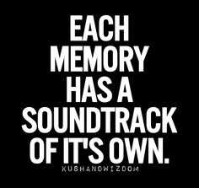
Now that you have identified the possible significant events, narrow it down to the six that you feel will be the most important to you personally. At least two should be from the past, but on the other hand, at least two should be from the future! Put them in the order in which they have occurred or the order in which you would prefer that they eventually occur.

Remember, everyone has a different idea of what matters and each person’s life will contain a variety of events. Your list shouldn’t be exactly the same as your classmates’…
- ______________________________________________________________
- ______________________________________________________________
- ______________________________________________________________
- ______________________________________________________________
- ______________________________________________________________
- ______________________________________________________________
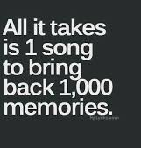
STEP 3: Make Connections.
For each event you have chosen, identify a song that somehow connects to this event. Maybe the lyrics somehow express your feeling at the time, or the theme/overall main idea fits. The song itself could just be a reminder of the event. It does not have to be an exact match, but be sure to read the whole song before you select it! Note: the lyrics of the song must be appropriate and cannot include extreme profanity or any derogatory remarks toward any race, gender, sexual orientation, and/or religious affiliation. You MAY NOT use the song “Happy Birthday” or “Pomp and Circumstance” (the graduation march).
STEP 4: Write.
To go along with each song title, you will need to write at least one paragraph (5 or more sentences) explaining the event and why you chose this song to fit it. The format of each paragraph should be different!! I do not want to see the same phrases repeated over and over again- make a detailed connection between the event, your feelings about it, and the song you chose! If needed, you can explain a little about the song’s history (if it connects) and even make a reference to a specific quote from the song lyrics, though nothing too long.
“Walking on Sunshine” by Katrina and the Waves- Getting my first real job after college
Graduating from college in the spring of 2001, I went through many job interviews trying to find a school to begin my teaching career. At the end of August, while I was away on vacation, I received a call on my cell phone from JTMS, asking me to come in for an interview. I rushed home, super excited, and within 48 hours, I was hired! For the next week, I did feel like I was 'walking on sunshine'! The singer describes walking around in a great mood, saying “I feel alive”.
STEP 5: Create.
Now you need to choose what type of format your project will take. You may EITHER create it on a poster board (white strongly suggested, but not required), paper or on your computer. Your project should have two sides:
- Left Side- You will need to create a cover with the title “Soundtrack of My Life” and your own name, along with an image or images that relate to you/your life in some way. It should fill the side of the whole page, from edge to edge. The lettering should be large, and as neat as possible. The whole thing should contain color!
- Right Side- List your songs in order, along with the event and the paragraph (use example format shown in Step 4). This should also be in a larger font size, be very neat (suggest typing) and easy to read! Remember to plan out- there are six songs that need to be listed! You may choose to type or neatly handwrite your paragraph and then cut it out and paste it to the posterboard, which is strongly suggested.

Below are samples of Album/CD cover
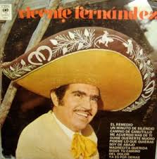
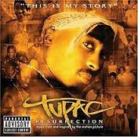
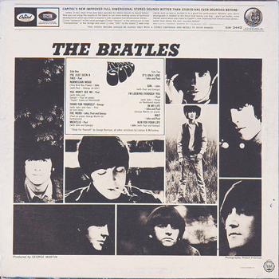
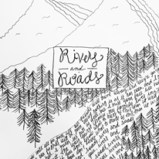
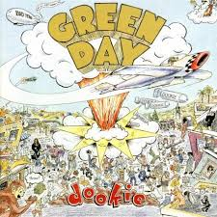
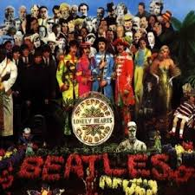

Soundtrack to Your Life Rubric
Level | 7-8 | 6-5 | 4-3 | 2-1
Criterion C:  Producing Text | Produces texts that demonstrate a high degree of personal engagement with the creative process; demonstrates a high degree of thought or imagination.  - 6 songs with events  - project always demonstrate creativity in meaning and/or artistry | Produces texts that demonstrate considerable personal engagement with the creative process; demonstrates considerable thought or imagination.  - 5 to 4 songs with events  - project usually demonstrate creativity in meaning and/or artistry | Produces texts that demonstrate adequate personal engagement with the creative process; demonstrates some thought or imagination.  - 3 songs with events  - Project sometimes demonstrate creativity in meaning and/or artistry | Produces texts that demonstrate limited personal engagement with the creative process; demonstrates limited thought or imagination.  - 2 or fewer songs with events  - Project rarely demonstrate creativity in meaning and/or artistry

